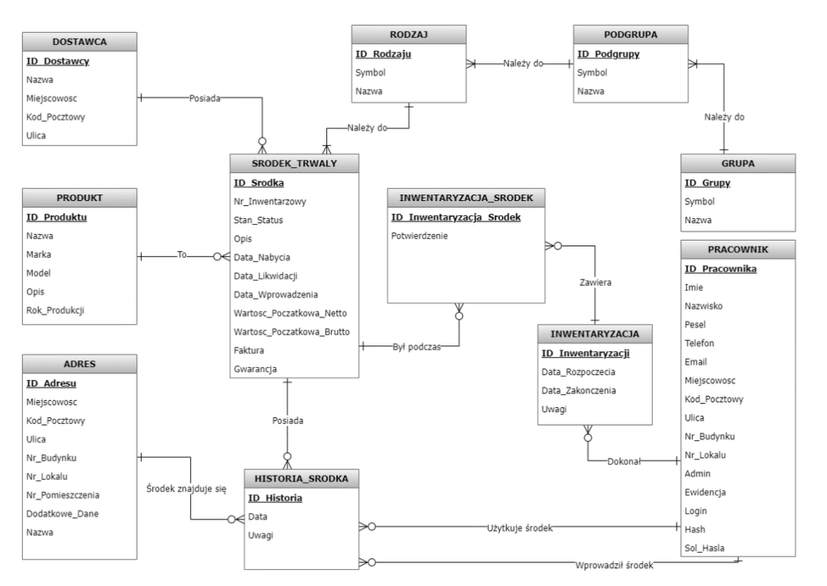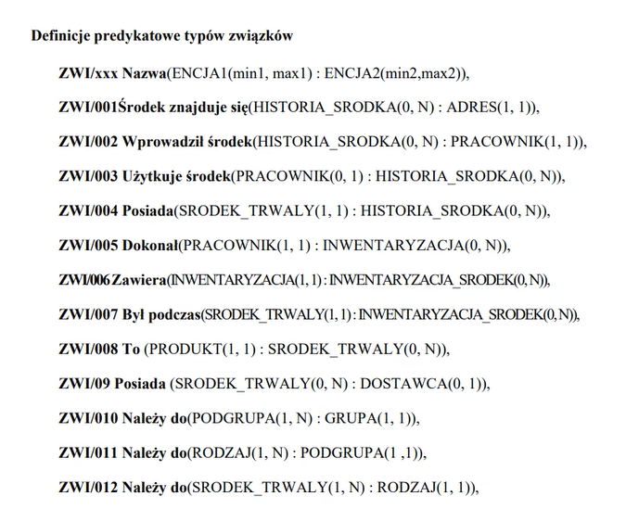

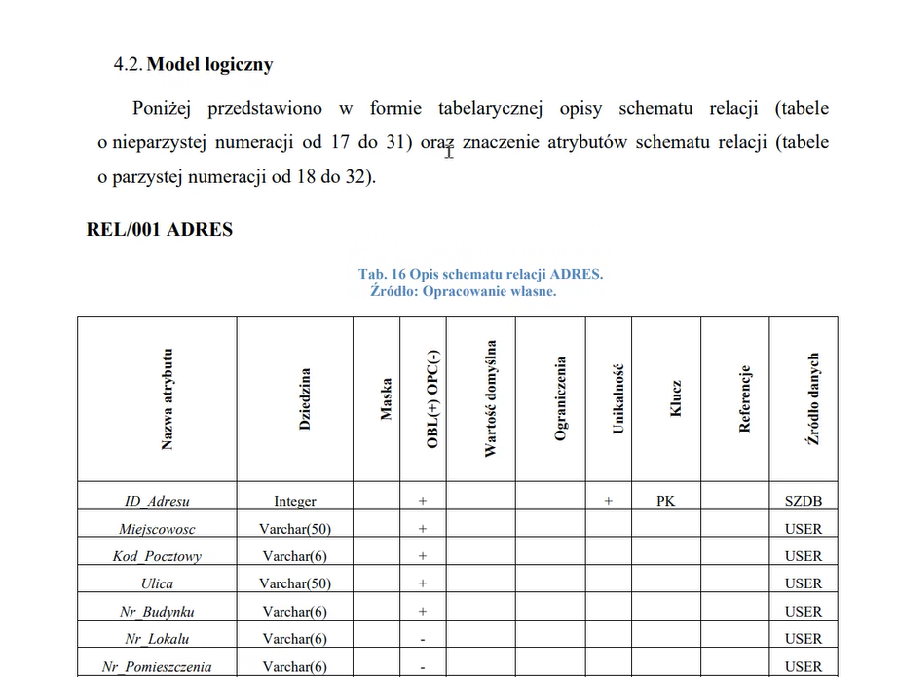

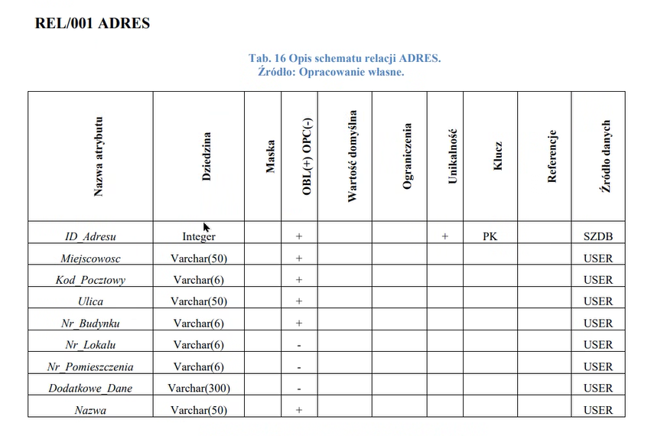

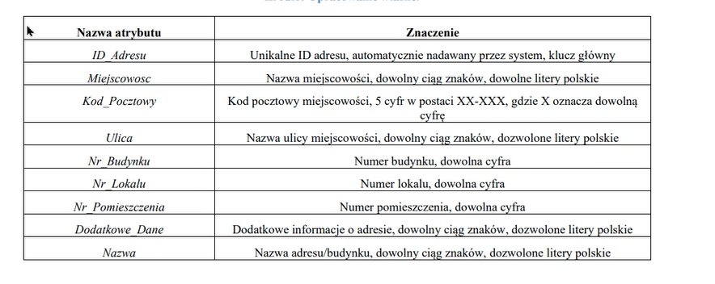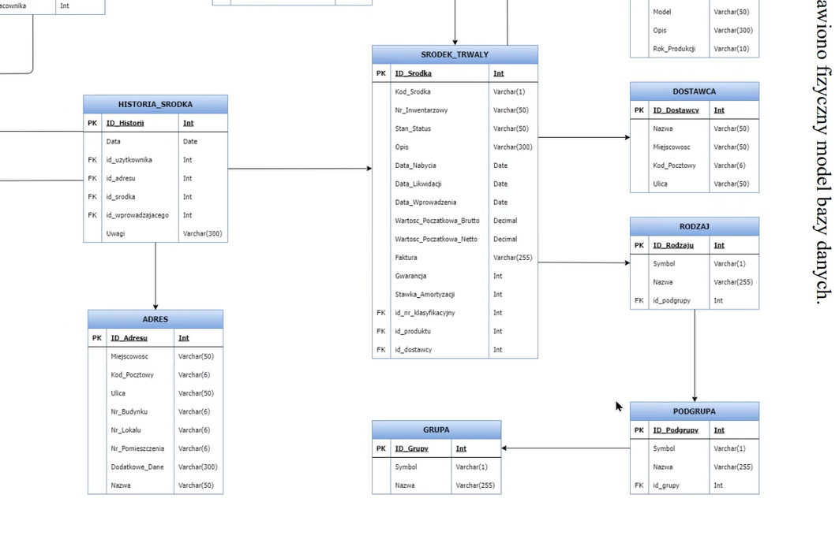

Swimlane;shape=table;startSize=30;container=1;collapsible=1;childLayout=tableLayout;fixedRows=1;rowLines=0;fontStyle=1;align=center;resizeLast=0;horizontalStack=0;

swimlane;fontStyle=2;align=center;verticalAlign=top;childLayout=stackLayout;horizontal=1;startSize=26;horizontalStack=0;resizeParent=1;resizeLast=0;collapsible=1;marginBottom=0;rounded=0;shadow=0;strokeWidth=1;